Writing Extended Responses to Questions - Make it
C.L.E.A.R.

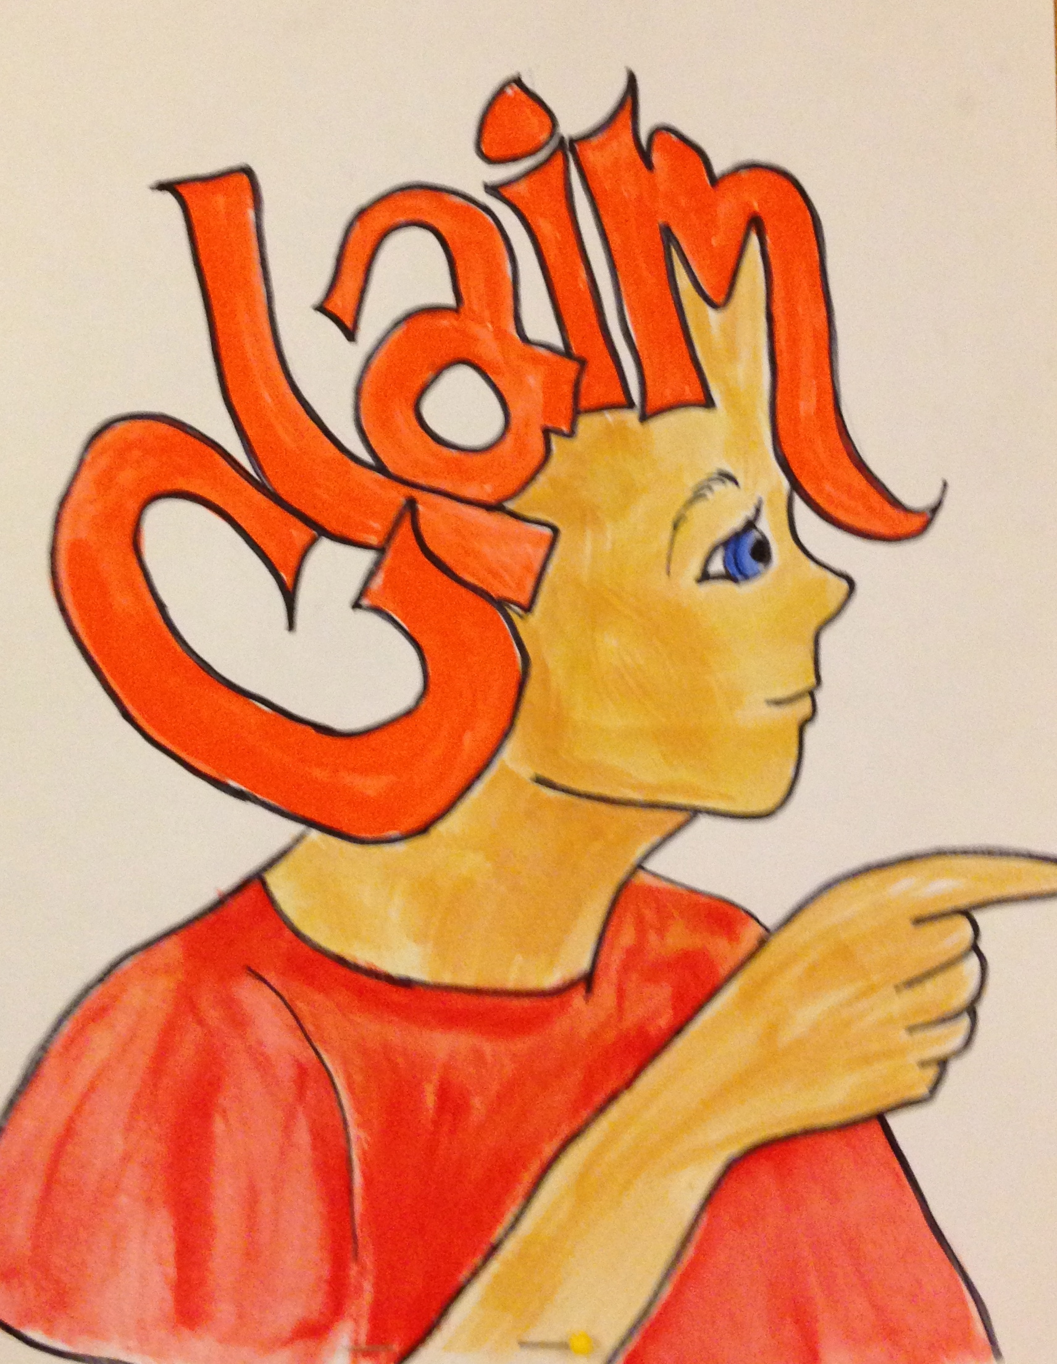
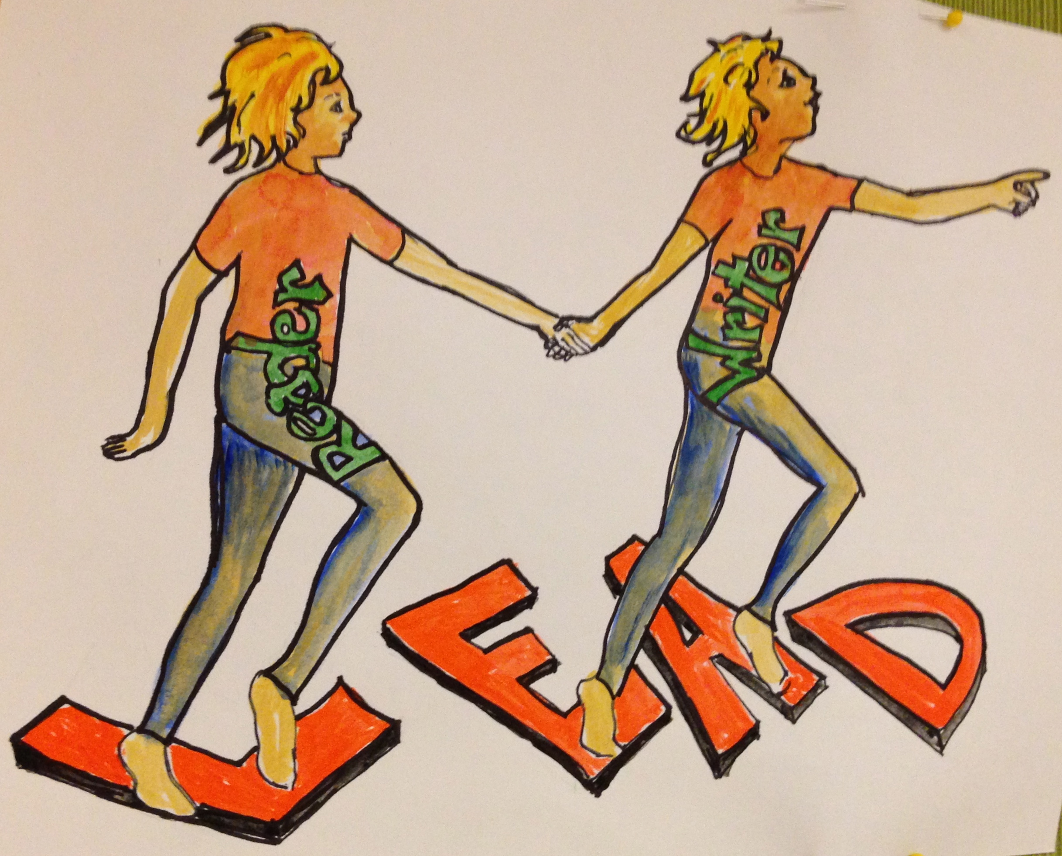
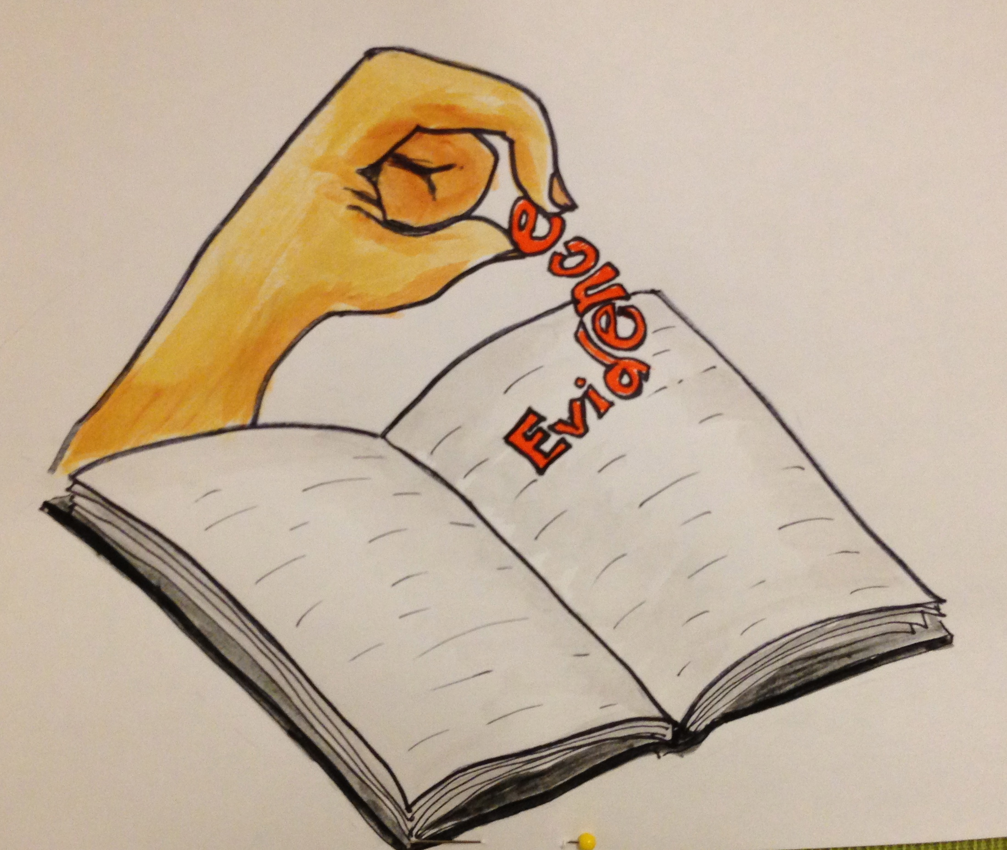
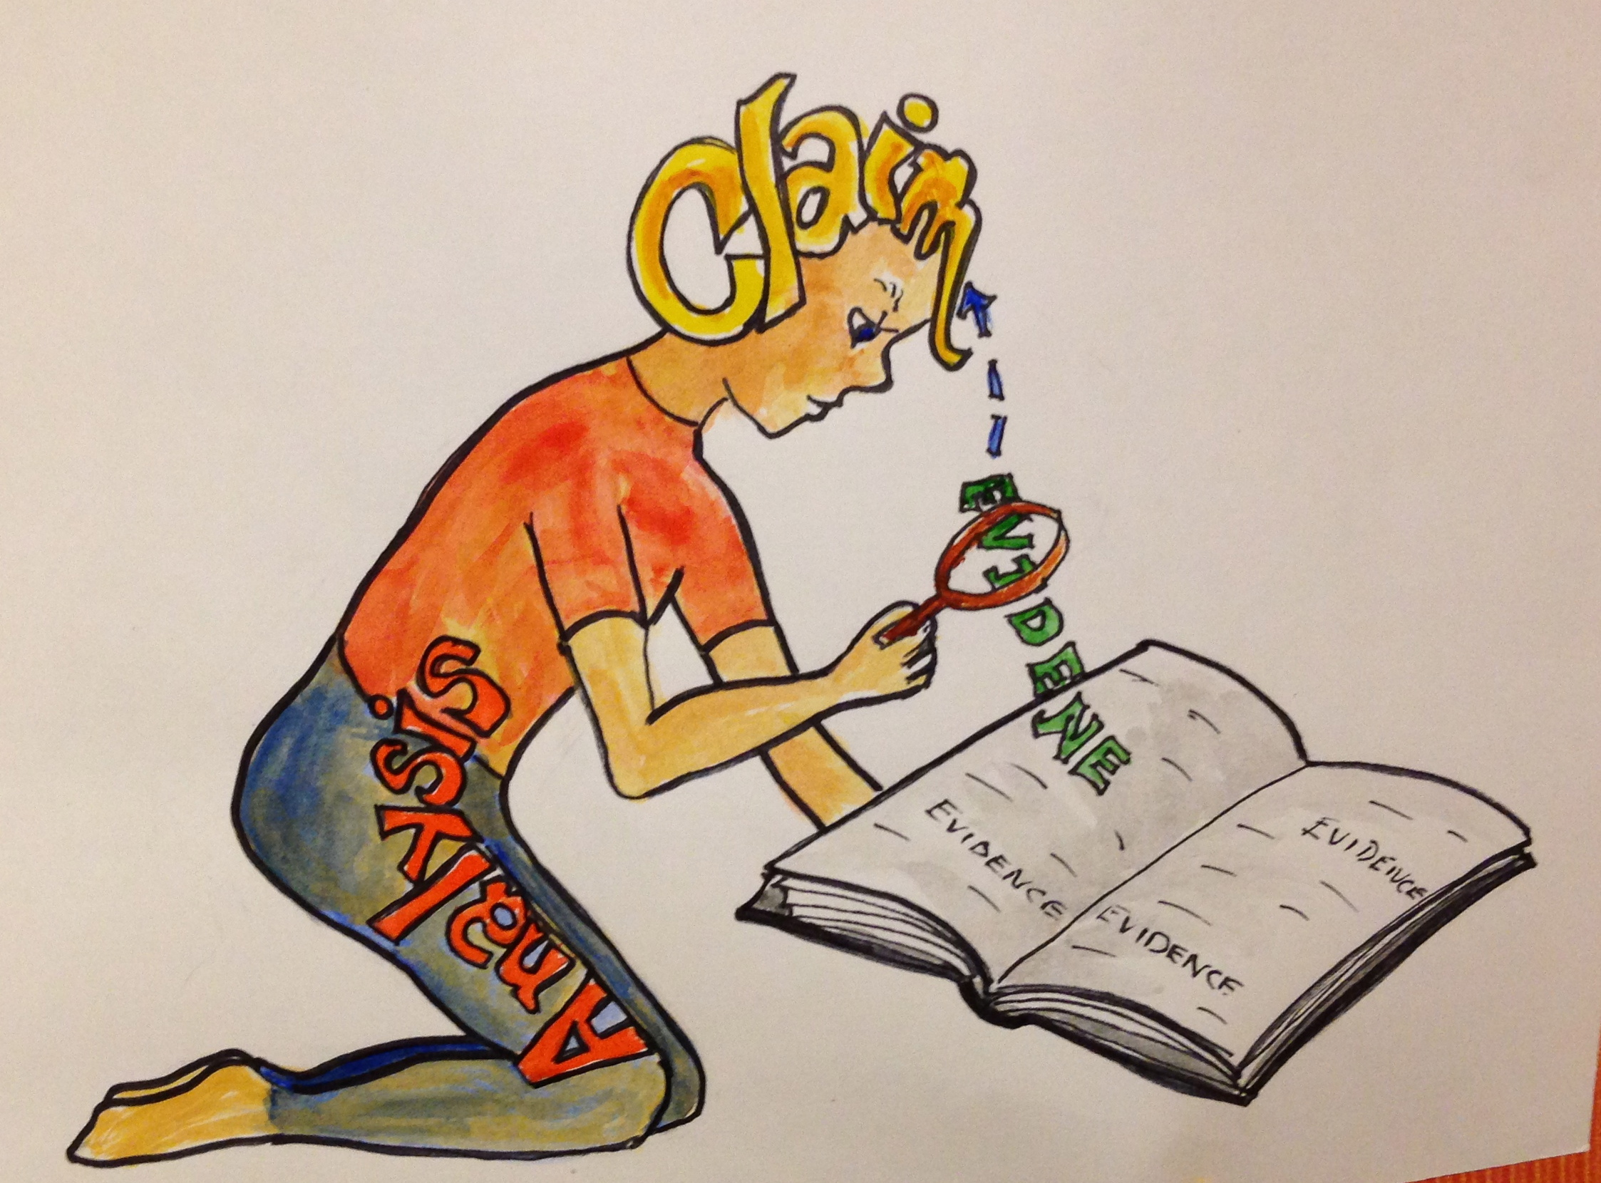
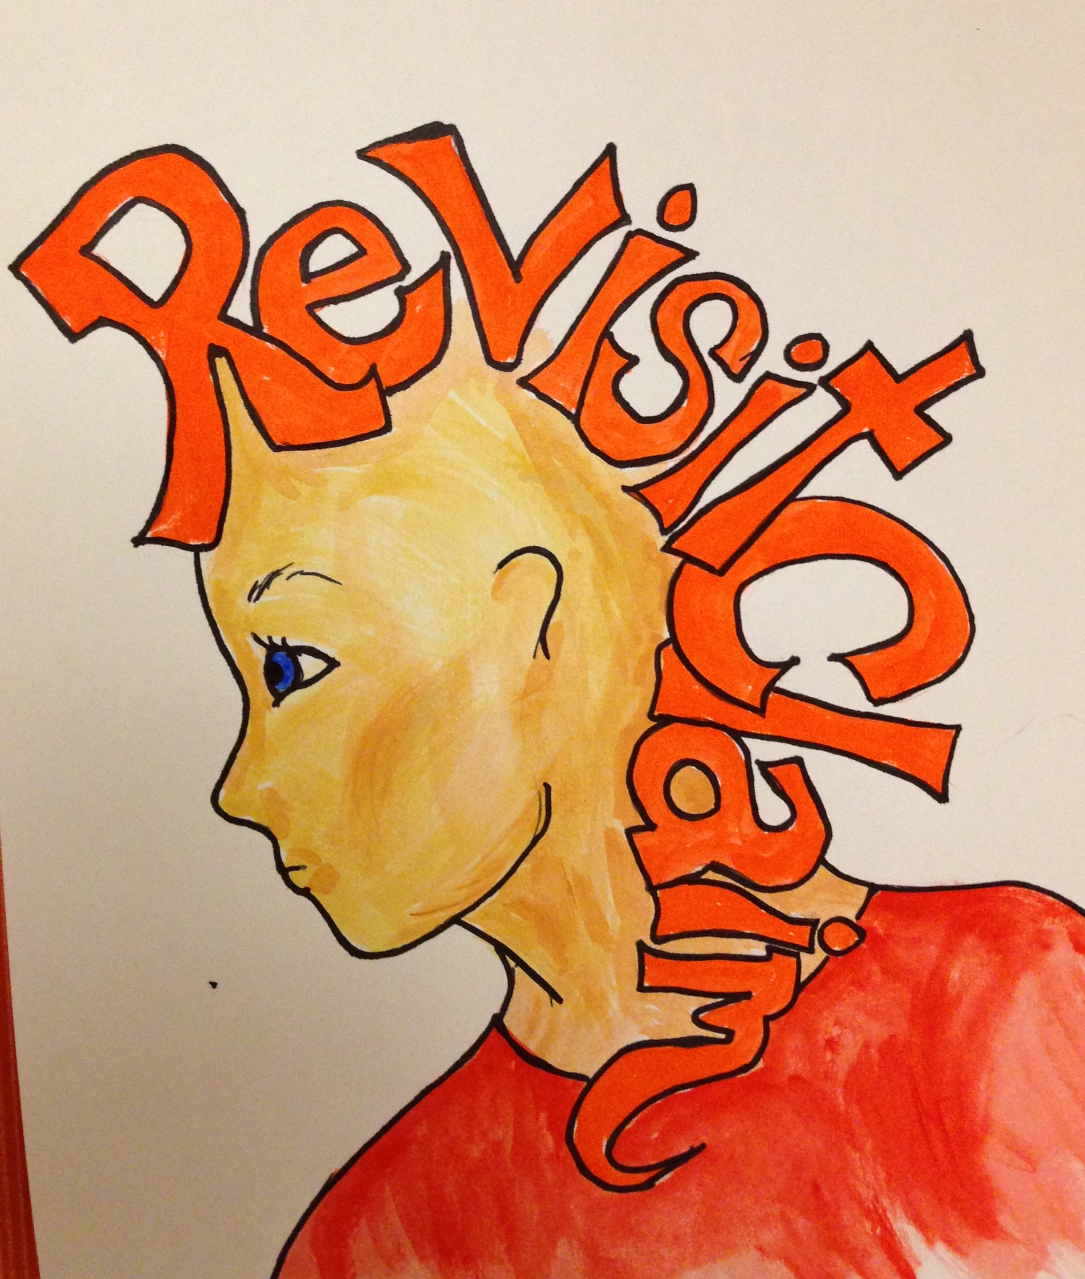

Claim – This is the actual stating of your claim and is the first step to writing an extended response.
- Claims take two forms in an extended response: as a thesis and as topic sentences.
- Do the following to write your thesis: take the question and turn it into a statement that answers the question.
- Your thesis will sometimes make several claims.
- Topic sentences ALWAYS come from your thesis and address separately each claim made in the thesis.
Lead – This is the process of leading you reader from your claim to your evidence.
- This is the section of your response that helps lead your reader from you claim to the evidence you will use to support your claim.
- This is comprised of contextual information or background knowledge that is necessary in order for your reader to follow your thinking. For example, you might need to provide your reader with pertinent historical facts in order for you reader to understand your argument.
- This may also include transitions that help introduce your evidence such as, According to the author . . . or In Harper Lee’s novel, To Kill a Mockingbird, the character Scout states . . .
- Think of the Lead as the path from your claim to your evidence
Evidence – This is the crucial information taken from the text that supports your claim
- In formal test situations, Evidence always comes directly from the text. Your opinion or personal experience is NOT considered strong evidence.
- Not all Evidence is created equal. You must select the BEST evidence from the text to support your claim. If you can’t find strong evidence to support your claim, change your claim.
- When providing the evidence you have selected to support the claim:
  - You can quote the evidence directly from the text using quotation marks.
  - You can paraphrase the evidence from the text as long as you make clear that the ideas and information you have described belongs to the author of the text.
Analysis – This is your argument for why your claim is valid and supported by the text
Following your evidence, you should write the following usually in this order:
  - Summarize the explicit message of the text evidence.
  - Share your interpretation of any implicit message embedded in the text evidence.
  - Explain how the evidence supports or refutes your stated claim (in your thesis or your topic sentence).
Revisit Claim - This is your conclusion and where you punch home your argument.

- Begin by summarizing significance of major ideas/content/conclusions that you presented in response
- Be sure to revisit the thesis without restating it
- Be sure you Do Not introducing new claims that you have not made.
- Your conclusion is best constructed if your last sentence wraps up your argument by referencing back to something you stated in the introduction.

Claim – Claims are made in a thesis and in topic sentences
Lead - Lead your reader from the claim to the evidence
Evidence – Select the best evidence available from the text
Analysis - analyze why your evidence strongly supports your claim
Revisit - Reiterate the validity of your claim

