Introduction | Lead to (step 4):  1) Contextual information to aid comprehension  2) Go from general to thesis
Claim: (thesis) (step 1)
Convert question into a statement
Body Paragraph | Claim: (topic sentence) (step 2)  Take directly from the thesis:
Lead to (step 4):
1) Contextual information to aid comprehension

2) Introductory clause to evidence
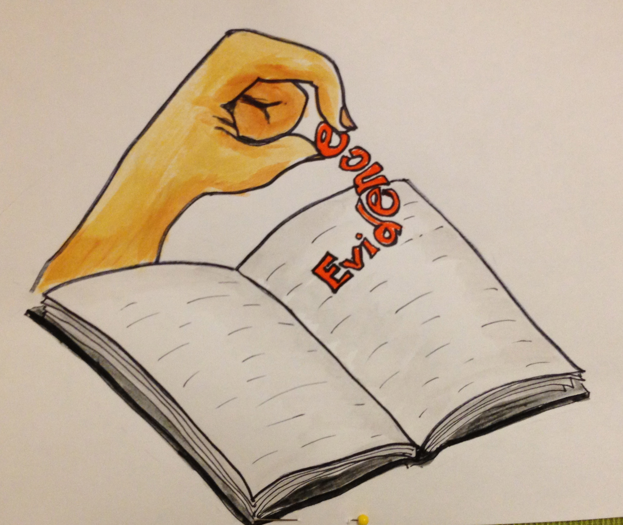
Evidence (step 3):
Take directly from the text:
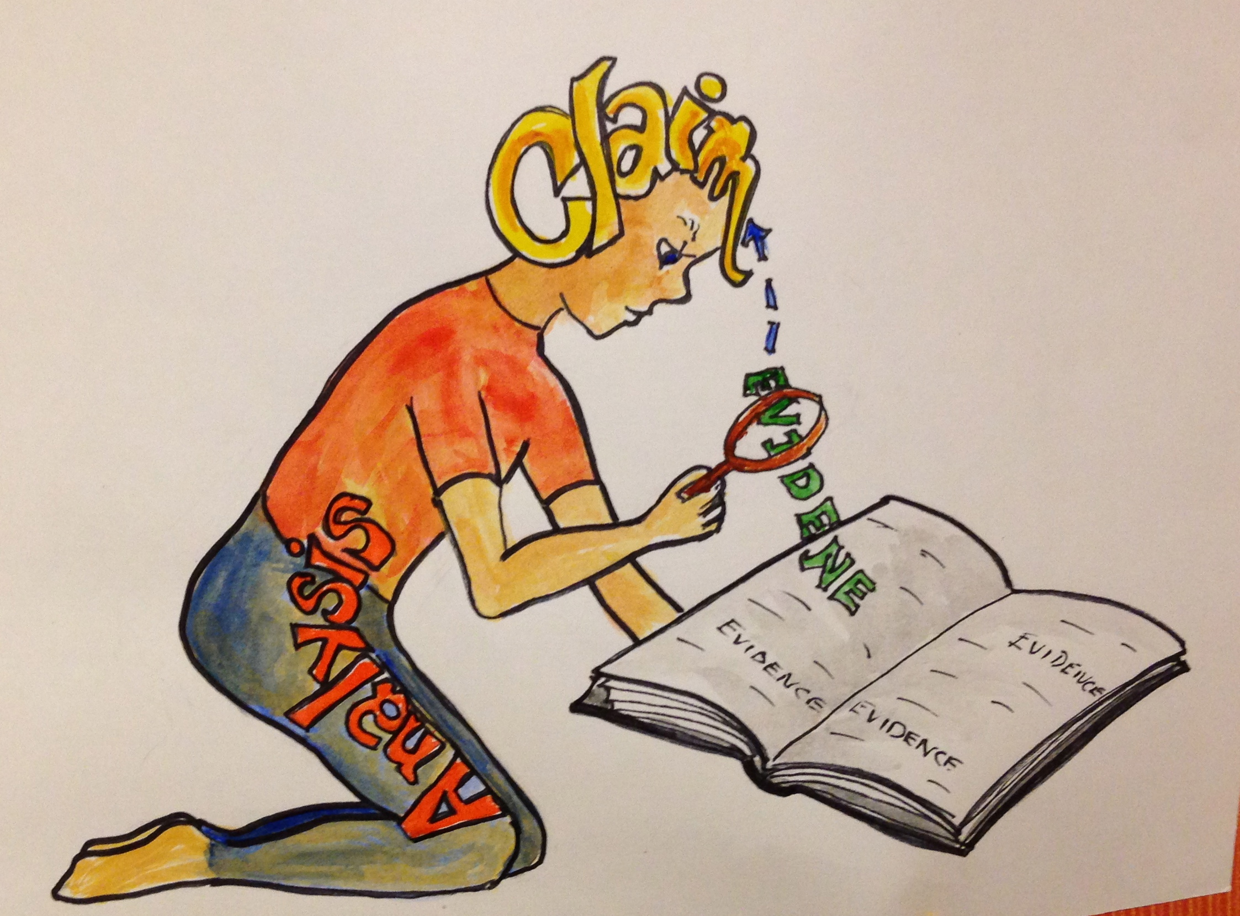
Analysis (step 5):
1) summarize explicitly

2) summarize implicitly

3) Explain how it supports claim
Conclusion | 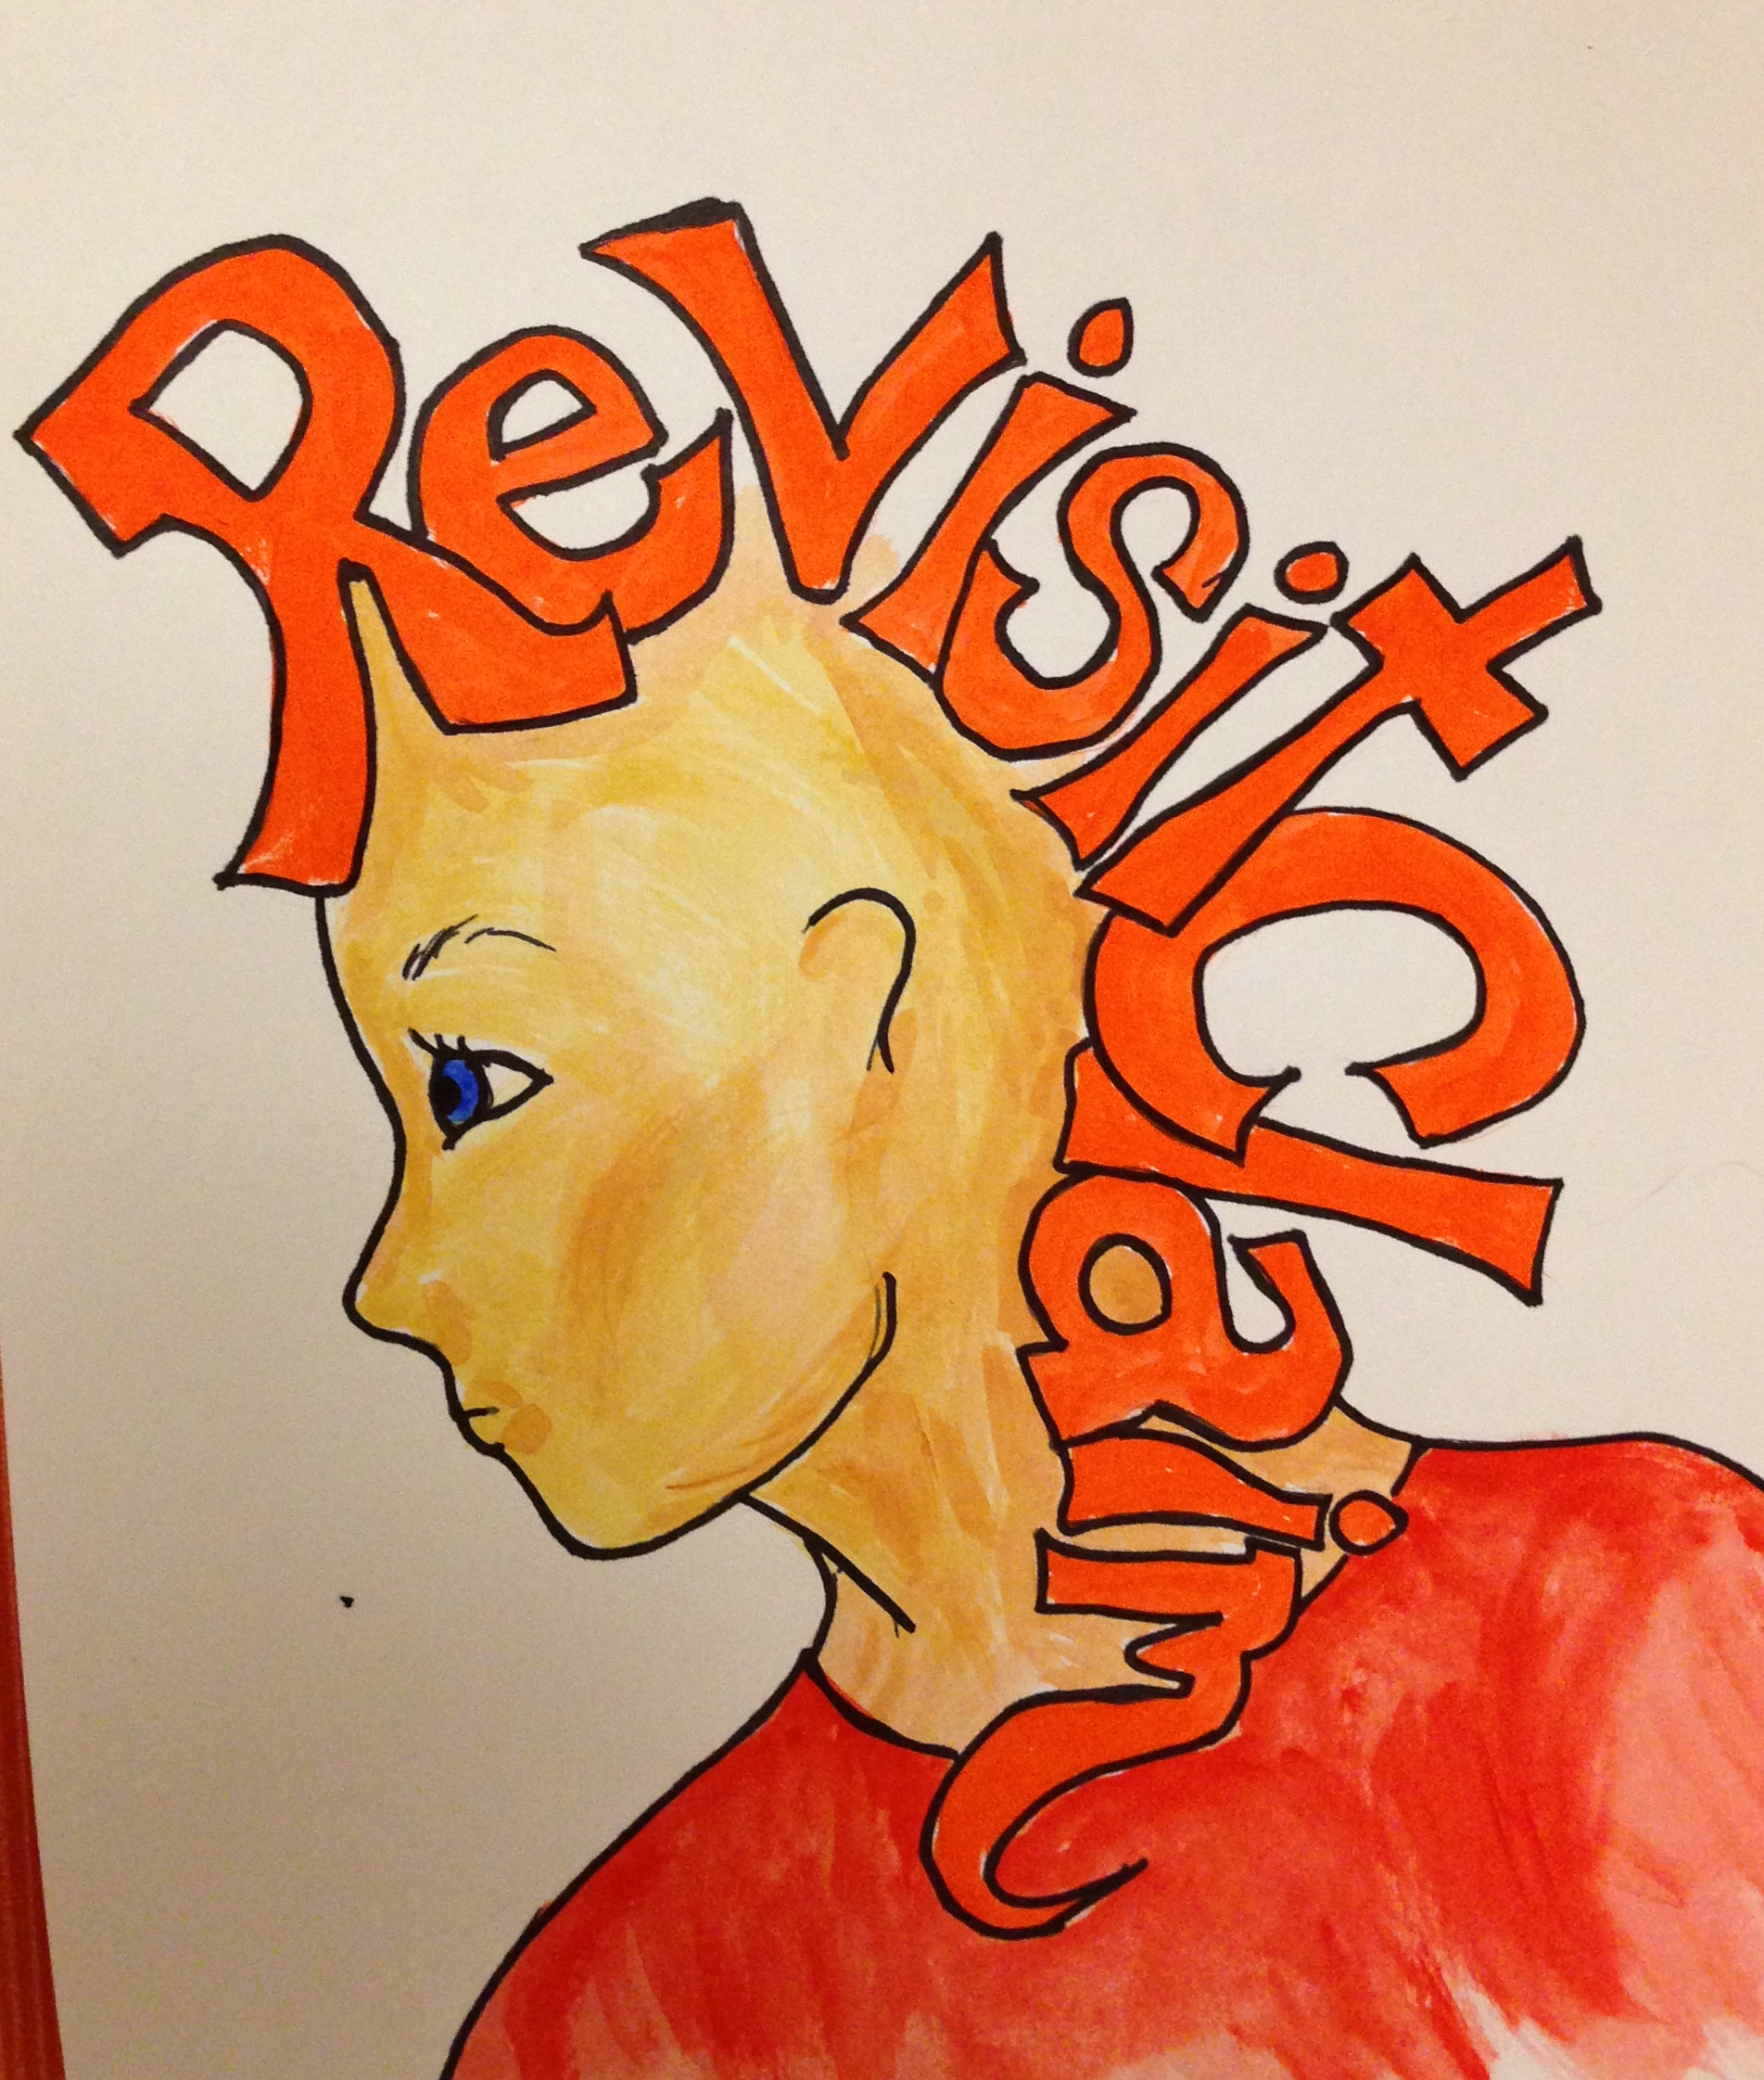  Revisit Claim (step 6)  1)State the validity of your claim and its importance:  2)Hook back to something in Introduction (Lead to):

