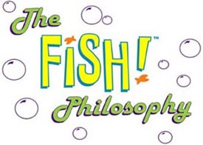

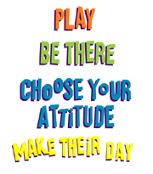

And will develop . . .

- Changing and Learning: Believe that through hard work you will continue to grow as a learner
- Critical Curiosity: Develop the habit of critically curiosity through questioning and analytical thinking
- Meaning Making: Develop the habit of connecting new knowledge to old knowledge to build deeper understandings
- Creativity: Maintain an open mind to different perspectives and understandings, to look at and see things in new ways
- Resilience: Value constructive feedback and see it as an opportunity to grow
- Learning Relationships: Value learning relationships for their ability to broaden your perspective and add to your knowledge
- Strategic Awareness: Develop the habit of reflecting on your strategies and assessing their effectiveness, adjusting them when needed

Yearly Minimal Requirements

Read Alouds - (120 – 175) | Lifelong Learning Strategies
Independent Reading Books (25) | Class presentations (3)
Q or Q’s – (100- 150) | Socratic Circle (min. 2)
Book talks/reviews (3) | Annotation / Analysis of text (3)
Reflection /Self-assessments (3) | Formal Papers
Vocabulary - Daily | Purpose of Education (1) (PBL)
Grammar - Daily | I-search paper (1) (consists of 5 sections)
Assessments | Creative writing (1)
MAP (3) | MLK/The Children’s March paper (1)
Explore (1) | This I Believe Essay (1)
Literacy Common Assessments (6) | The Stories We Carry (1)
ISAT | Shakespearean Scene (1)
Vocabulary / Grammar quizzes (weekly) | Dystopian short story (1)
 | The Great American Teen Novel (1)

